Week 1 task:

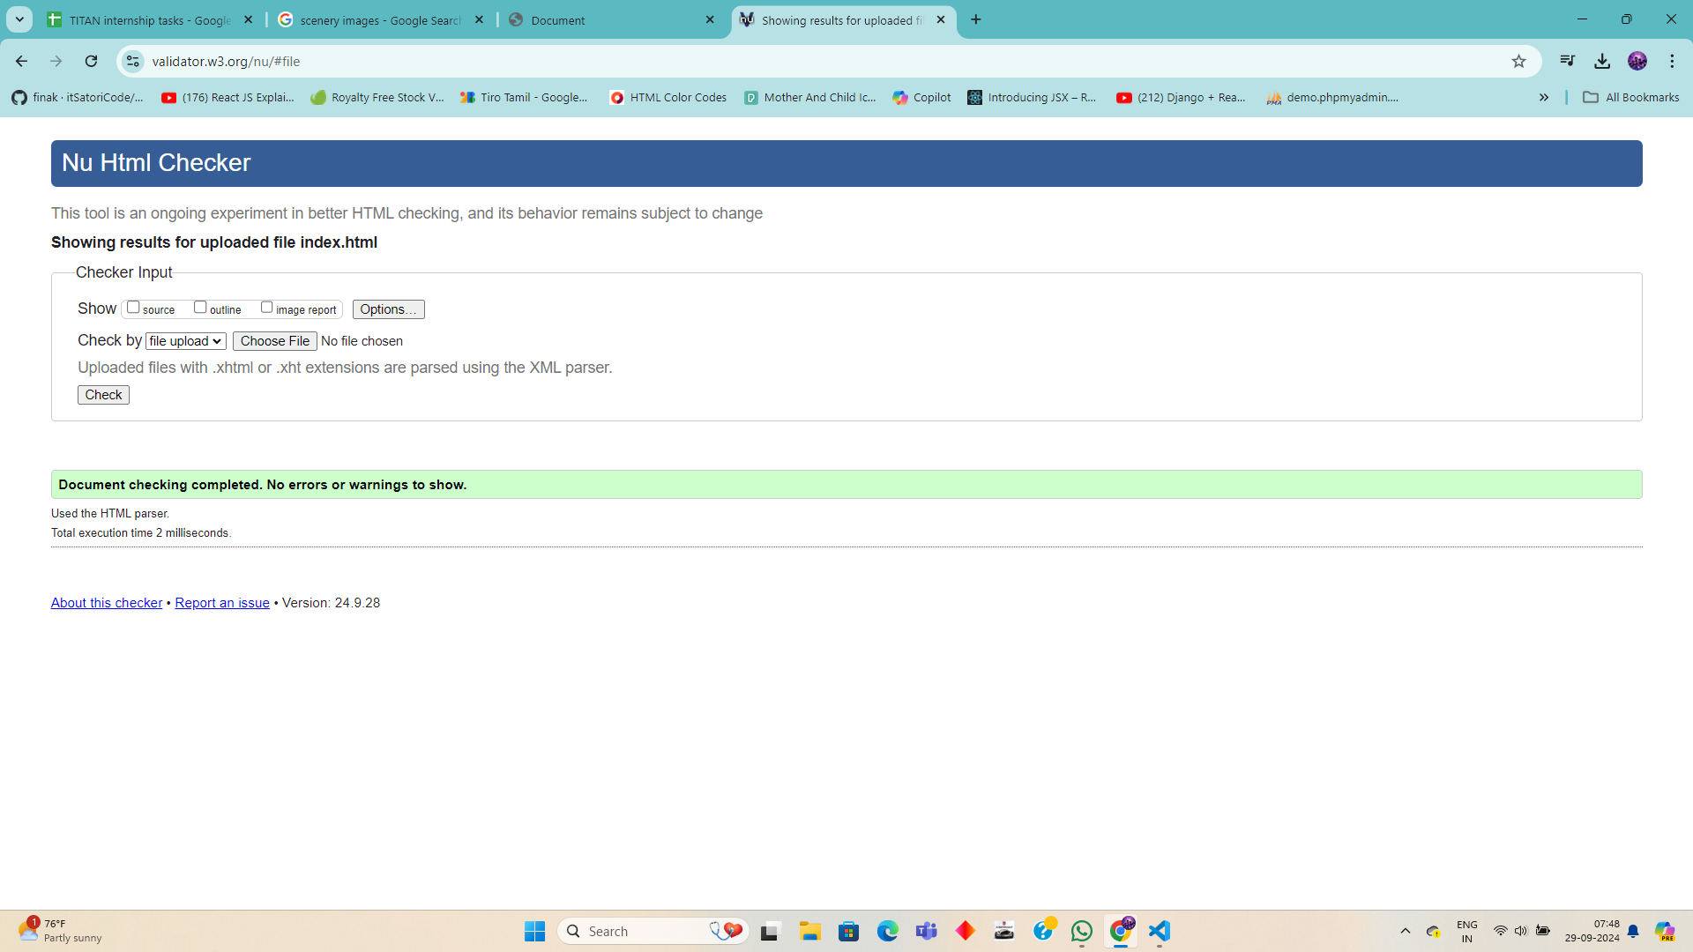

<!--  Build a simple webpage with headings, paragraphs, and images.

   - Validate your HTML with the W3C Validator.

 -->

<!DOCTYPE html>

<html lang="en">

<head>

    <meta charset="UTF-8">

    <meta name="viewport" content="width=device-width, initial-scale=1.0">

    <title>Document</title>

</head>

<body>

    <h1>Hello I am Banusri from Dr NGPit</h1>

    <h2>Currently in the training for titan internship</h2>

    <p>Lorem ipsum dolor sit amet consectetur adipisicing elit. Perspiciatis beatae, consectetur unde quo labore velit facilis, tenetur illo iste quia omnis reprehenderit quas ad accusantium cum ea? Impedit, nulla ducimus!</p>

    <img src="asset/image.jpeg" alt="image">

</body>

</html>

Week 2: